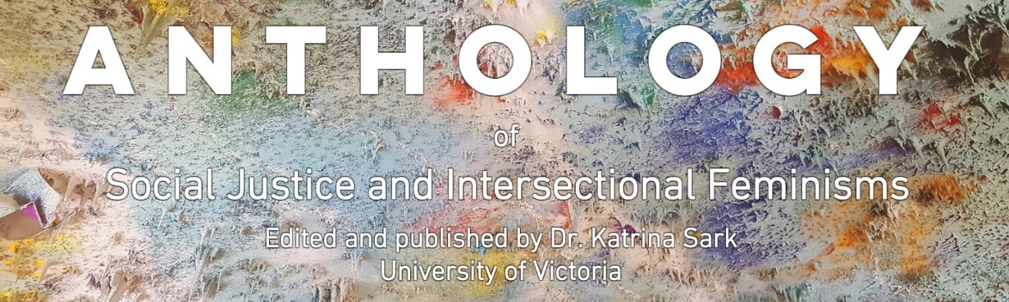

Contest Application Form:

Second Volume
Anthology of Social Justice and Intersectional Feminisms

CATEGORY | FORMAT | GUEST JUDGES
Best research essay | WORD doc, 5-10 pages max, double spaced, not counting notes and bibliography, in-text bracket citations only | Boma Brown – founder of Support Network for Indigenous Women & Women of Colour (sniwwoc)
Best poem | WORD doc, 1-3 pages | Waaseyaa’sin Christine Sy – lecturer in Indigenous Gender Studies at University of Victoria, creative writer and poet
Best grassroots activism report | WORD doc, 1-3 pages | Uma Mishra-Newbery – director of Global Community of Women’s March Global
Best photo or art piece | 1-3 JPEG images – labelled with artist’s name, image title/description, location and date | Chorong Kim – award-winning filmmaker and photographer

PRIZES (for each category):
- Publication, feature, and write-up in the second Volume of the Social Justice Anthology
- Award Certificate signed by the guest judge
- Intersectional-feminist and social-justice-themed gift baskets worth $150 each (with books, art, stationary, and other gifts)
- A printed copy of the published Anthology
- An invitation to a discussion panel during the official launch of the Anthology on March 8, 2019

TOPICS:
- Indigenous feminisms, justice, decolonialization, resurgence, resistance, sovereignty and leadership
- Social justice education and pedagogies (teaching, learning, research and scholarship)
- Solution-based activism (strategies and inspiration)
- New directions and innovative approaches to feminism, (social) justice, decolonialization, and environment

BIO: Please include a short bio (2-3 sentences max) with your submission
SUBMISSION GUIDELINES: Please email your submission as a WORD DOCUMENT, with the application form (below), as well as a non-refundable application and administration fee of $25 (e-transfer or cheque) to the editor Kat Sark at katrina.sark@mail.mcgill.ca with the subject line: Social Justice Anthology, no later than December 15, 2018.
MULTIPLE SUBMISSIONS: Applicants can submit to more than one contest category, but have to include an application form and fee for each category.
SELECTION CRITERIA: Our guest judges will select the best piece for each category, but the top three contenders will be published in the Anthology.
Contest announcements will be on January 15, 2019. Official launch and prizes awarded on March 8, 2019.
Application Form
Name: | Email address (and web link if available):
Affiliation: | City of residence:
Contest category you wish to be considered for: | Submission date:
Title of submission:

Short bio (2-3 sentences max – to be included with your publication):

Application fee (non-refundable $25 per submission) sent by (e-transfer or cheque) to the editor, Kat Sark (katrina.sark@mail.mcgill.ca) on (date):

